Margins, Markups, and Break-Evens

©2010 Richard P. Rumelt. This work is licensed under a Creative Commons Attribution NonCommercial 4.0 International License (CC BY-NC 4.0). You may copy, distribute, and adapt this material for non-commercial purposes, provided appropriate credit is given. Commercial use requires written permission from the author.

Table 1 shows a Profit and Loss (P&L) report for a company for the year ended 1999. The P&L is a report for a particular period, in this case one year. In accounting you will get into the details about how each of the numbers in this report are defined and measured. Right now we will think of revenues as all the money taken in by selling goods and services. The “cost of goods sold” (CGS) measures the manufacturing costs incurred in making the products sold (not in making all products, only in making the products actually counted in revenues). The components of CGS are (a) raw material costs, (b) inbound shipping costs, (c) energy costs, (d) manufacturing labor costs, (e) plant maintenance expenses, (f) losses due to theft and accident (shrinkage), (g) inventory storage costs, and (h) quality control costs. CGS can also be influenced by changes in prices and foreign exchange rates.
Examine Table 1 and think about how the P&L might differ between two similar firms. Revenues might differ because one sold more units than the other; but revenues might also differ because one charged prices that were higher than the other! So comparing revenues between firms involves a certain amount of mixing of apples and oranges. This is almost inevitable in business calculations (if you want purity, stick to mathematics).
TABLE 1
Profit and Loss Statement
(Expenses are shaded) | $ (000) | Percent of  Revenue | Type of Margin
Revenue | 225,000 | 100.0%
Cost of Goods Sold | 82,500 | 36.7%
Gross Profit | 142,500 | 63.3% | Gross Margin
Selling, General & Administrative Expense | 75,000 | 33.3%
EBITDA | 67,500 | 30.0% | EBIDTA Margin
Depreciation & Amortization Expense | 20,000 | 8.9%
Operating Profit | 47,500 | 21.1% | Operating Margin
Interest Expense | 12,000 | 5.3%
Profit Before Income Taxes | 35,500 | 15.8% | PBT Margin
Taxes | 12,070 | 5.4%
Net Profit | 23,430 | 10.4% | Net Margin
Analysis starts with comparison. If we were to compare the CGS numbers between two different companies, it wouldn’t tell us very much. To compare, we must have a common basis of measurement or of scaling. So comparison, or analysis, starts with finding a common base. Most analysts start P&L comparison by scaling everything to revenue. Given this scaling, when we compute the ratio of CGS to revenues (36.7% in this case), we are measuring the importance of manufacturing costs relative to revenues. Comparing CGS/Revenue from one year to the next is a good way of tracking one aspect of a firm’s efficiency.
Whether comparing such a ratio over time or between firms, interpretation is not always easy. CGS/Revenue might be lower in one case because purchased materials were cheaper and in another because manufacturing expense was lower. CGS/Revenue might be lower in a third case because the company’s prices were higher. [Stop! Make sure you understand the above paragraph].
So the first lesson in simple business measures is “be careful.” Think it through. There are very few “plug it in and wind the crank” calculations you can do with accounting numbers without getting into some kind of difficulty. Almost all accounting numbers are mixtures and your comparisons may reveal differences in performance or efficiency, or they may instead simply reflect differences in the mixtures. That doesn’t mean you shouldn’t work with accounting numbers⎯most of the time, they are all you will have to describe the internal workings of a company. Learn how accounts are produced in order to understand what the numbers say and how to make adjustments in order to see what you want to see.

Margins
Gross Profit is defined as Revenues less CGS, and the Gross Margin is the ratio of Gross Profit to Revenue. In this case, Gross Margin is 63.3%. That is, out of every dollar in revenues, 36.7% is chewed up by CGS, leaving 63.3% to cover other costs and profit.
Moving down the P&L, the next major item is Selling, General and Administrative Expense (SG&A). Note that we do not count SG&A as part of Cost of Goods Sold—this is because it is normally quite difficult to allocate these expenses with any accuracy to particular products or batches of production. More technically, these are “expenses” rather than “costs. That is, they are more attached to a specific period of time than they are to a particular volume of production.
Sometimes a company will report Selling Expense separately from G&A Expense. These expenses are also sometimes called “overhead” because they cannot be logically associated with units produced or sold. In this case, overhead is 33.3% of revenue. One might be interested in whether this was high or low for the industry, and in whether it was changing materially over time for the company.
The profit available after subtracting SG&A is called EBIDTA (earnings before interest, depreciation, taxes, and amortization). It is often the figure that investment bankers focus on in merger and takeover discussions. This is because EBIDTA represents real “cash” profits before the effects of financing, taxes, and fictitious depreciation and amortization charges. It is thus the cash that a sufficiently smart and sophisticated buyer might extract from the firm.
Operating Profit = Gross Profit – SG&A – Depreciation & Amortization. It is “operating” because it does not take into account financing expenses (like interest) and extraordinary expenses. Corresponding to Operating Profit, we define Operating Margin as the ratio of Operating Profit to Revenue. In this case the Operating Margin is 30%.
The next margin we could define is the ratio of Profit Before Income Tax to Revenue (PBT Margin). Finally, we have Net Margin, the ratio of Profits After Tax (or Net Income) to Revenue.

Cash Flow
Depreciation and amortization are not real expenses. They are accounting conventions. Depreciation is a charge written into the accounts to deal with the idea that fixed assets like plant and equipment are wearing out and will have to be replaced. Depreciation reduces reported profit by the estimated amount of the wear-out during the period. The point is to make sure that the company doesn’t overestimate its earning power and start paying all of its profit out to shareholders as dividends and then not have any cash left over to replace equipment. Amortization is like depreciation, but refers to things other than physical assets⎯and amortization is generally not a tax-deductible expense, as is depreciation.
The upshot is that Net Income understates the cash thrown off by operations. To get CFO (cash flow from operations) we simply add depreciation and amortization back in. In the case at hand
CFO = 23,430 + 20,000 = 43,430.
What this means is that at the end of the year the company has shown $23,430 in Net Income, but it actually generated $43,430 in new cash to work with.

Markups and Margins
In retailing, and in looking at channels of distribution in general, the word margin has a slightly different meaning. We have just discussed most of the kinds of margin that are calculated for manufacturing firms. However, when a retailer talks about margin it is usually just the difference between selling price and purchased cost. If he buys an item for $10 and sells it for $15, the margin is $5 and the percent margin is 5/15= 33.3%.
Terms like margin resist precise definition because people in different industries working in different roles use them differently. In a retail chain, when the CEO says margin she probably means operating margin. When the head of retail store says margin, he probably means gross margin (revenue less CGS). When the merchandising manager says margin, she probably means the difference between selling price and purchased cost (leaving out the other elements of CGS).
A markup is also a term from retailing. It is the percentage by which a selling price exceeds the purchase cost of an item. Like retail margins, markups are normally calculated from raw purchase prices without counting any handling or operating overhead. If a retailer buys an item for $10 and sells it for $15, the dollar markup is the same as the dollar margin: both are $5. However, the percent margin uses the price as the denominator, whereas the percent markup uses the cost as the denominator. Thus, in this case, the $5 is a 5/10 = 50% markup. This 50% markup corresponds to a 33% margin. When setting prices, the retailer tends to think about markup, because he starts with cost and works upwards. When thinking about profits, he tends to think about margin, as that is what is available to cover expenses and profits.
The whole thing is less confusing if we use symbols. Let m be a margin, computed as
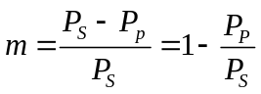
where P_{p} is the purchase price of an item and P_{s} is its selling price. Note that this margin is a ratio, not a percentage. (If you want a percentage, multiply it by 100.) A markup u is defined as
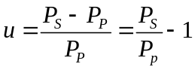
From these expressions, one can see that the basic relationship between the two is most directly expressed as
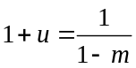.
From this, it is easy to solve for either m or u:
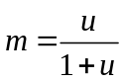 and 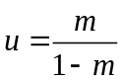.
These formulae are useful in dealing with the conversion between margins and markups.

Distribution Channels
We sometimes have to combine margins or markups across levels in a distribution system. In these cases, the following relationships are useful. Suppose that there is a two-level distribution system. At the wholesale level there is a margin m₁ and another margin m₂ at the retail level. A markup ratio is (1+u)⎯the amount we multiply the supply price by to get the selling price. From , the wholesale markup ratio is 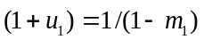and the retail markup ratio is 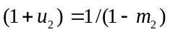. Hence the markup ratio for the whole system is
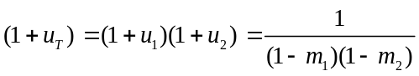
and, since 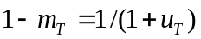, the margin for the whole system is
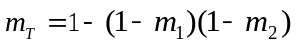.
Generalizing, we see that markup ratios combine easily⎯you just multiply them together. Margins don’t combine so easily⎯you have to use , which amounts to converting them to markup ratios, multiplying the ratios together, and then converting back to a margin.

Exercise
A manufacturer sells a product for $200 to a wholesaler. The wholesaler margin is 20%. The wholesaler sells to a distributor whose margin is 15%. The distributor sells to a retailer who has a selling margin of 50%. What is the retail-selling price?
Answer:
We know that markup ratios multiply over stages in a channel. The wholesale markup ratio is 1/(1-.2)=1.25. The distributor’s markup ratio is 1/(1-.15)=1.1765. Finally, the retail markup ratio is 1/(1-.5) = 2.0. The markup ratio for the whole chain is just the product of these, so
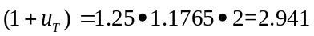.
Hence the retail selling price is 200x2.941=$588.24.

Break-Evens
Although accountants divide costs into CGS, SGA, depreciation, interest, taxes, etc., in economic analysis we tend to think of three categories of cost: sunk fixed investment, fixed costs, and variable costs. For the moment, we will ignore sunk fixed investment. Fixed costs are those costs that do not change with the rate of production. They are the basic price of being in business. Variable costs, by contrast, vary with the rate of production or sales. The situation is shown in Exhibit 1.
Now, look at Table 1 and try to identify the fixed and variable costs. Variable costs change with the rate of production. Fixed costs are constant per period, though they stop if the firm stops operating. Sunk investments are past costs that are unchanged by a stop in operations.
EXHIBIT 1
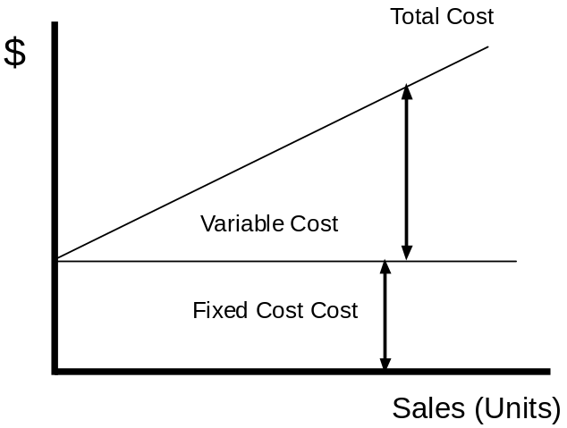
The first thing to notice is that accountants simply don’t divide costs up this way. So you have to either (a) abandon the attempt, (b) make some assumptions, or (c) undertake a study using more detailed data.
Here, we will plow ahead with the simplest assumption: CGS are variable and SG&A are fixed. Ignore depreciation and amortization, they are sunk. Ignore interest, it is about financing, not operations. Given these assumptions, the company’s “profit” (actually EBITDA in this case) is defined as
Profit = [Revenue] – [CGS] – [ SG&A].
Let M be the CGS margin. Let the fixed costs F be SG&A. Assuming that price is unchanged, and letting R stand for revenue, profit is
Profit = RM – F.
Then the break-even condition (zero profit) is simply
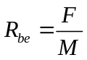.
That is, the breakeven level of revenue is $75,000/0.633 = $118,483. Revenues below that level will produce losses; revenues above that level will produce profits. All assuming that we have actually identified the fixed and variable costs and that variable costs per unit do not change with the rate of production.
It is often useful to dig deeper and deal with the break-even level of output (rather than revenue). Suppose the company’s unit output Q during the period was 122,000 units. Now we know the average price per unit P = R/Q = 225/122 = $1.844, the variable cost per unit V = CGS/Q=82.5/122 = $0.6762. The contribution C per unit is defined as the amount of gross profit per unit. That is,
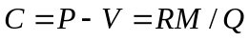.
In this case, C = 142.5/122 = $1.168. To break-even, the firm must sell enough units so that the sum of their contributions covers fixed costs. That is, the break-even quantity is
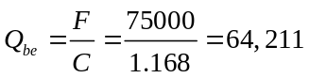.
To get break-even relationships, write the basic profit condition in whatever form is most appropriate for the issue at hand:
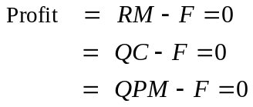.
Each of these expressions is useful in different situations.

Break-Even’s on Policies and Decisions
In the above calculations we looked at the break-even of the firm as a whole. However, the break-even concept is used much more frequently as a way of analyzing decision alternatives. By looking at changes in one variable, for example, we can ask how much another variable would have to change to restore the status quo. That is, to break-even on the decision (not the company).

Exercise
Zapata is considering an advertising campaign that will cost $50,000. How many extra units have to be sold to warrant this expense?
Answer: We are changing a fixed cost so the break-even condition is that operating profit be unchanged. The contribution per unit is still $1.168. To cover the extra fixed expense of the ad campaign, sales must increase by at least 50000/1.168 = 42,807 units.

Zapata is considering a 10% reduction in price. How much increase in demand must be generated to justify this price reduction?
Answer: With a 10% reduction in price, contribution per unit falls to C = (0.9xP-V)= $0.984. The wrong answer is to calculate the new company breakeven: 75000/.9836=76,250. This is wrong because the question is not how much must be sold to break-even as a company; the question is how much must be sold to keep profits the same—to break-even on the decision to change price.
Gross Profit was $142,500. With the new contribution Zapata would have to sell 142500/.9836 = 144,875 units to keep even. That means an increment of 22,875 units, a 19% increase in sales.

Issues
We began the section on break-evens by making swift assumptions, identifying variable cost with CGS and fixed costs with SG&A. There is a problem with this. First, many of the costs included in CGS are allocated manufacturing overheads, so they are really fixed, not variable. Secondly, many of the expenses assigned to SG&A do actually vary with output or sales, and are therefore variable. A careful analyst makes the distinction between accounting numbers and economic concepts. And a careful analyst goes further and realized that output Q is not the only important “driver” of costs. Costs can depend upon geographic spread, number of products, number of customers, number of transactions, etc.

If Q is the number of units sold, V is the unit cost, and P is the price, then CGS/Revenue= V/P.
For example, the buyer might recapitalize the firm with enough debt to wipe out accounting profits. The interest payments pass to the new owner, and depreciation is available for the repayment of debt. Taxes are eliminated by the large interest charge. Hence, the new owner can receive cash flows equal to EBIDTA.
Because depreciation is tax deductible, it creates a tax savings. That tax savings is real, not fictitious. To get cash flow from net income, we simply add back the fictitious expense deductions.
To add to the general confusion, retailers use the term markdown to refer to price reductions. This time the base is the prior selling price. So if we have the $15 item and “mark it down” by 33.3%, its selling price drops to $10. So we see that a 50% markup is reversed by a 33.3% markdown.

